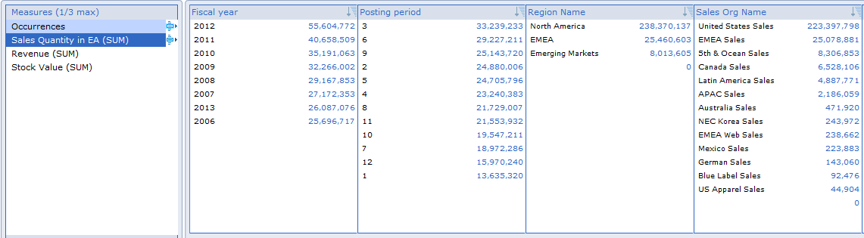Region: All C:\Users\markh\AppData\Local\Microsoft\Windows\Temporary Internet Files\Content.IE5\TYICLIDZ\MC900432674[1].png

**Product Mix**  **License**

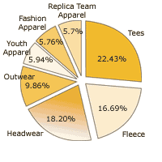

**Region = All** C:\Users\markh\AppData\Local\Microsoft\Windows\Temporary Internet Files\Content.IE5\TYICLIDZ\MC900432674[1].png **Region= All**C:\Users\markh\AppData\Local\Microsoft\Windows\Temporary Internet Files\Content.IE5\TYICLIDZ\MC900432674[1].png

**Currency = USD**C:\Users\markh\AppData\Local\Microsoft\Windows\Temporary Internet Files\Content.IE5\TYICLIDZ\MC900432674[1].png **Top N= 5** C:\Users\markh\AppData\Local\Microsoft\Windows\Temporary Internet Files\Content.IE5\TYICLIDZ\MC900432674[1].png

**Currency= USD**C:\Users\markh\AppData\Local\Microsoft\Windows\Temporary Internet Files\Content.IE5\TYICLIDZ\MC900432674[1].png

For the data dimensions please allow for the same fields that are in Query VMP_OPASA_Q002

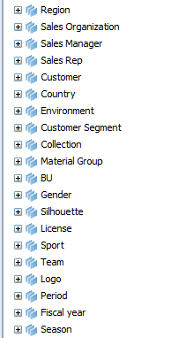

The spaces above should have parameters as shown. For Region, Top N License, Currency.