Currency Conversion Files Update Process
Overview
There are five currency conversion files that are used by crystal reports for currency conversion namely:
- Exchange Rate
- Sales Org Exchange Rate
- Monthly Exchange Rate
- Sales Org Monthly Exchange Rate
- Currency Conversion Rates.
The above mentioned files need to be updated every first day of a new period with the current period exchange rates. These values can be identified using T-Code 'OB08' in NEP (New Era ECC Production System).

File Content
Here are the contents of these files:
- Exchange Rate – This file has the conversions between source and target currencies along with Company Code and contains only current period exchange rates.

- Sales Org Exchange Rate - This file has the conversions between source and target currencies along with Sales Organization and contains only current period exchange rates.

- Monthly Exchange Rate - This file has the conversions between source and target currencies along with Company Code, Fiscal Year and Period. It contains previous, current and future period’s exchange rates. Also the current period exchange rates are updated in this file as well as copied to all future periods.

- Sales Org Monthly Exchange Rate - This file has the conversions between source and target currencies along with Sales Organization, Fiscal Year and Period. It contains previous, current and future period’s exchange rates. Also the current period exchange rates are updated in this file as well as copied to all future periods.

- Currency Conversion Rates – This file has the conversions between source and target currencies along with Fiscal Year and Period. It contains previous, current and future period’s exchange rates in ‘All Periods’ sheet and the current period exchange rates are updated in this sheet as well as copied to all future periods. There is a ‘Current Period’ sheet that contains the values for the current period only.

Navigational Steps:
Please follow the detailed steps as specified below:
Step 1: Open the Exchange Rate file: We need to update the cur_exchange_rt and USD column for each company code. USD column will always shows converted USD rates from from_currency column. cur_exchange_rt column will vary based on to_currency like AUD, CAD, GBP, HKD etc as shown below.
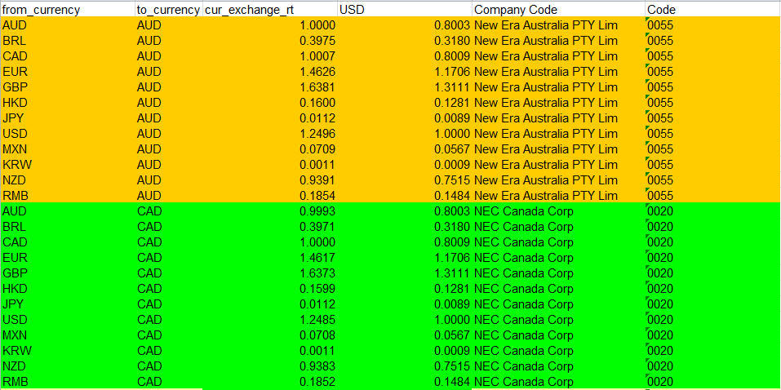

Step 2: Logon to NEP into T-Code ‘OB08’: Click change → display button to change to display mode from change mode as shown here:

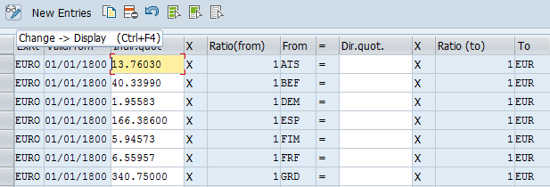

Step 3: Navigate to Selection Menu: Navigate to Selection menu > By Contents and Select To-currency and Valid From fields as shown below and click continue:

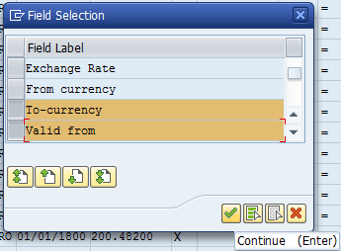

Step 4: Enter Prompted values: Enter To-Currency field value as USD and Valid from field value as the current period start date. For Example, for period 8 of 2017 enter the start date as 07/31/2017 and click Choose:

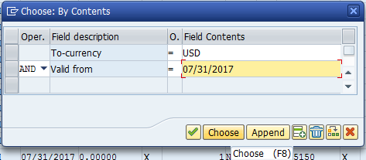

Step 5: Transfer Values into Exchange Rate file: Next the below conversion values will be displayed and they need to be updated into Exchange Rate sheet 'USD' Column as shown here:

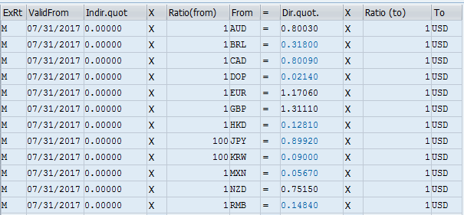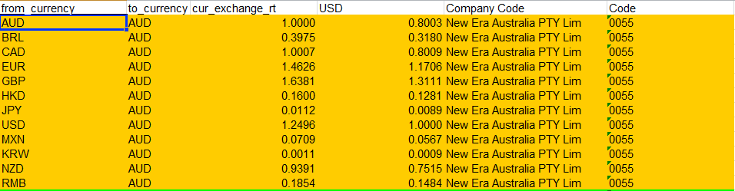

Repeat the 'USD' conversion values for all the company codes till the end of file.
Note 1: When updating the KRW and JPY values the value from ECC should be divided by 100 and result need to be updated in the sheet as shown above. For Example, KRW value in ECC is 0.09 this should be divided by 100 (0.09/100 = 0.0009) and the result value 0.0009 should be updated in the sheet.
Note 2: If the Ratio(from) field has 100 then divide by 100. For Example, in the above screenshot KRW value in ECC is 0.09 this should be divided by 100 (0.09/100 = 0.0009) and the result value 0.0009 should be updated in the sheet.
Note 3: If the Ratio(to) field has 100 then multiply by 100. For Example, in the below screenshot AUD value in ECC is 0.88980, this should be multiplied by 100 (0.88980*100 = 88.98) and the result value 88.98 should be updated in the sheet.
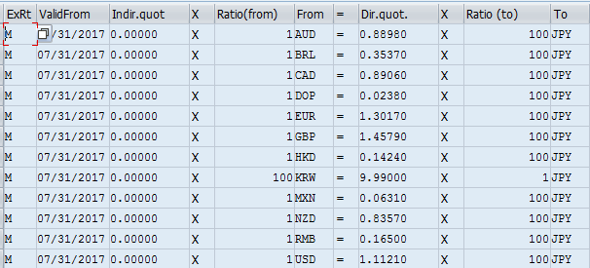

For conversions of other currencies change the To-currency to 'AUD' and update the values in cur_exchange_rt column. Repeat the same for other currencies in the sheet like 'BRL', 'GBP', 'HKD' etc.
Step 6: Update Sales Org Exchange Rate file: Open the ExchangeRate sheet and then copy paste the corresponding values from ExchangeRate sheet to Sales Org Exchange Rate sheet as shown here:
ExchangeRate Sheet:
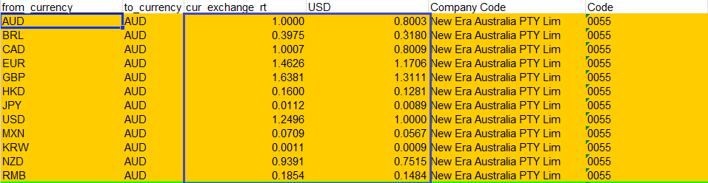
Sales Org Exchange Rate Sheet:
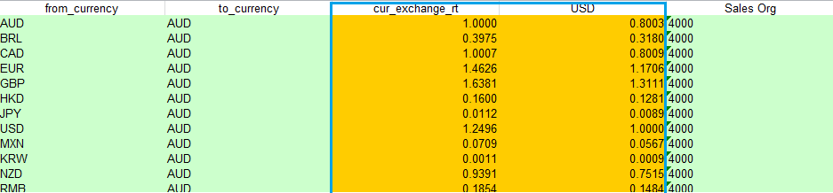

Step 7: Update Monthly Exchange Rate file: Next open the Monthly Exchange Rate sheet and update the current period values only and then copy the current period values to all future periods till the end of sheet. There will be no change in the values of previous periods.

- Navigate to Selection Menu: Selection menu > By Contents and remove the To-currency field and add the From-currency field as shown below and click continue:
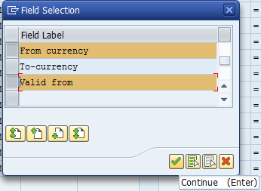
- Enter Prompted values: Enter From currency filed value as USD and Valid from field value as the current period start date. For Example, in the below screenshot for period 8 of 2017 enter 07/31/2017 and click Choose as shown below:
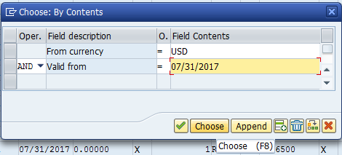
- Output Screen: Once choose button is clicked the following screen will appear:
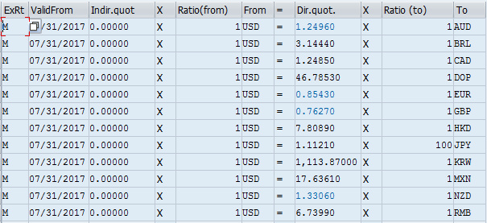
- Update File: Update the above values accordingly in the Monthly Exchange Rate sheet:

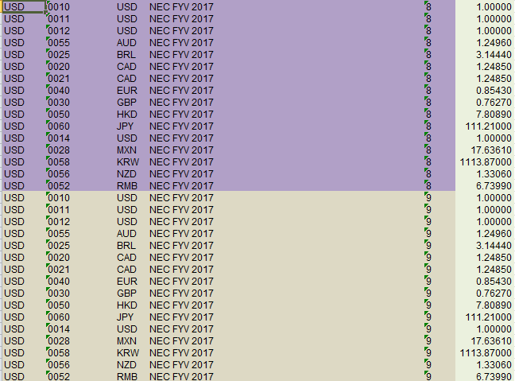

Step 8: Update Sales Org Monthly Exchange Rate file: Repeat the process in Step 7 again to update the Sales Org Monthly Exchange Rate sheet:
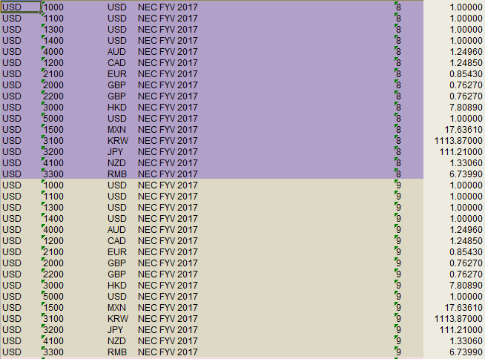
Step 9: Update Currency Conversion Rates file: Repeat the process in Step 7 again to update the Currency Conversion Rates file in ‘All Periods’ and ‘Current Period’ sheets:
All Periods sheet:
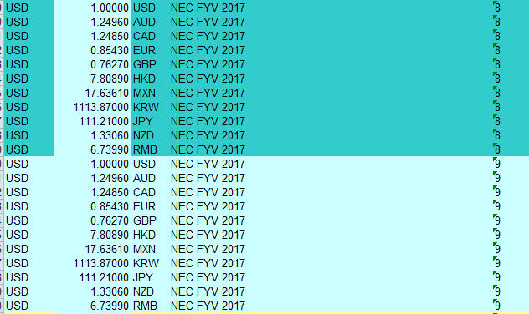

Current Periods sheet:
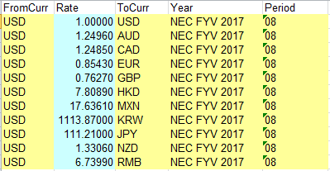

Step 10: Validation of files: Manually verify and validate the value and format of each cell that is updated after all above files are completed.

